# **Connect To Linux From Windows By Using PuTTY**

**Steps To Connect Linux From Windows By Using PuTTY:**

1. Download PuTTY from <https://www.chiark.greenend.org.uk/~sgtatham/putty/latest.html>

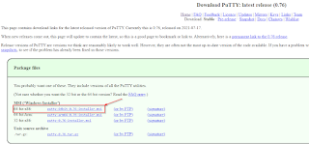

1. Install Putty.

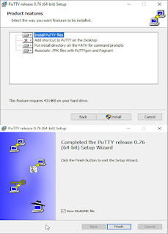

1. Launch the client.

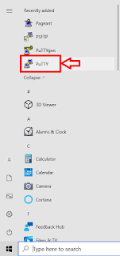

1. In the PuTTY Configuration window, in the Host Name field, enter the IP address of your Linux Server. Ensure that the connection type is set to SSH.

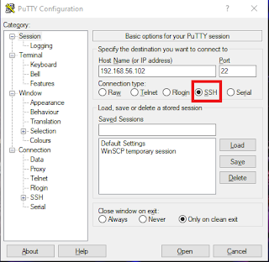

1. (Optional) In the Saved Sessions field, assign a name for this connection. Assigning a name saves time the next time that you use Putty. You can assign a different name for each of your Linux Servers.

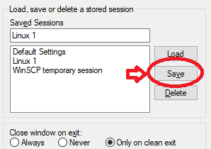

1. Click Open.



1. Enter your username and password.

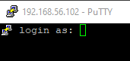

1. If you have entered the correct root password, the prompt responds with a shell prompt. Now you can work on your server.

